docker run -dit --name uptime-kuma -p 3001:3001 -v /var/run/docker.sock:/var/run/docker.sock louislam/uptime-kuma

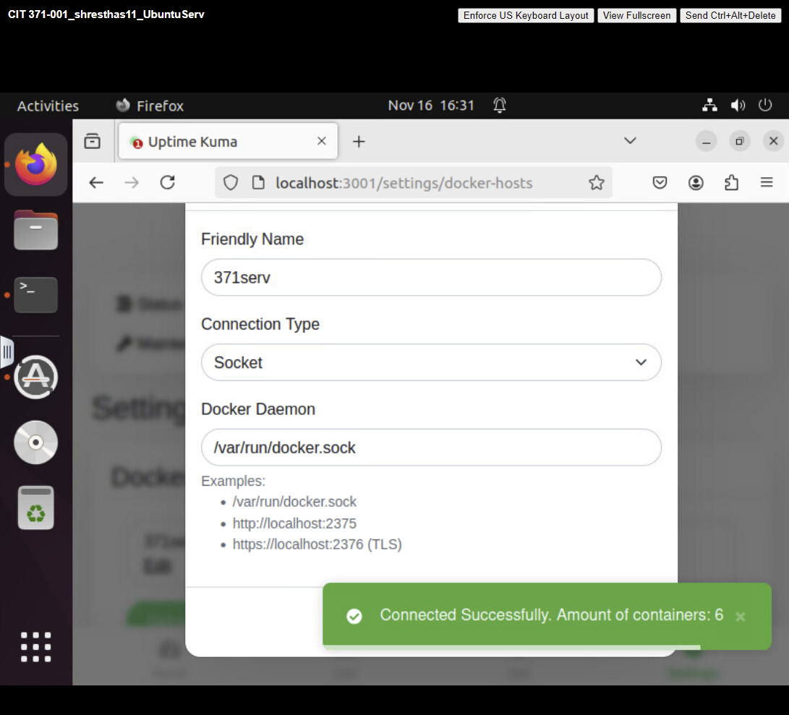

https://dns.google/

